http://www.homeandlearn.co.uk/net/nets4p15.html
http://www.java2s.com/Code/VB/GUI/CheckBox.htm

TO OPEN A NEW WEB FORM
Right click on the project name in the solution explorer ->in the menu select add->new item->in the dialog box which opens select windows form and click add
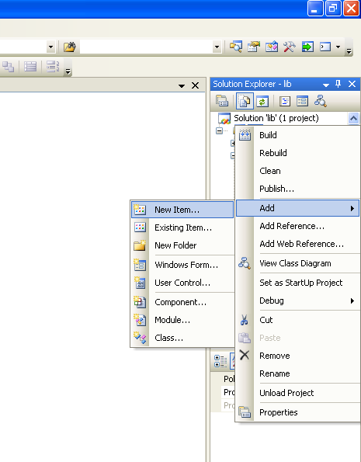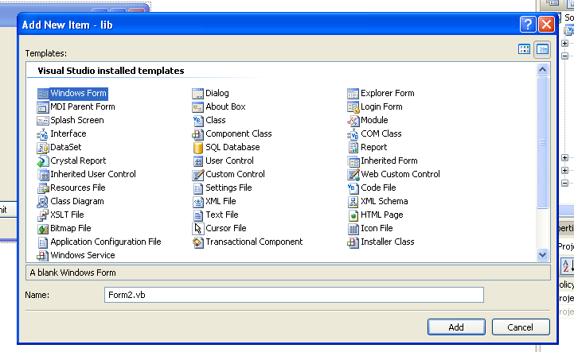

Form 1:
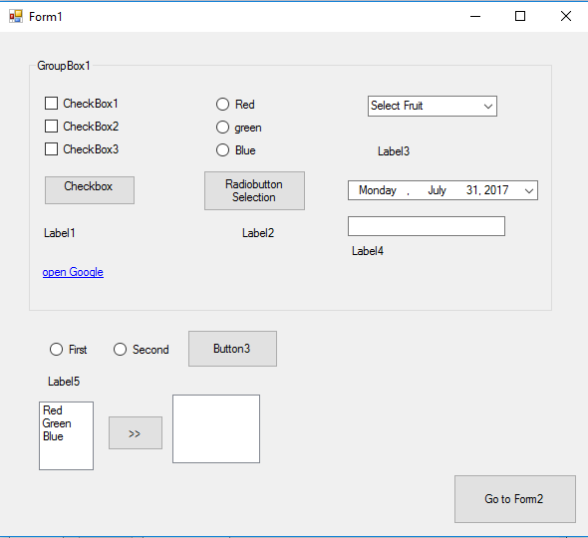
Form 2:
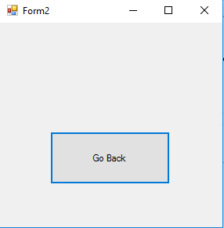

to move from one form to another on click of button
Dim F2 As New Form2()
F2.Show()
Me.hide()

Code for Button, label, textbox
Public Class Form1

Private Sub Button1_Click(ByVal sender As System.Object, ByVal e As System.EventArgs) Handles Button1.Click
Dim a As Integer
Dim b As Integer
Dim c As Integer
Me.BackColor = Color.Blue
a = Val(TextBox1.Text)
b = Val(TextBox2.Text)
c = a + b
Label2.Text = c.ToString

End Sub
End Class

Code for Check box selection /group box
Public Class Form2
Dim str As String

Private Sub Button1_Click(ByVal sender As System.Object, ByVal e As System.EventArgs) Handles Button1.Click
str = " "
If CheckBox1.CheckState = 1 Then
str = str + CheckBox1.Text

MsgBox("Checked 1")
End If
If CheckBox2.CheckState = 1 Then
str = str + CheckBox2.Text

MsgBox("Checked 2")
End If
If CheckBox3.CheckState = 1 Then
str = str + CheckBox3.Text

MsgBox("Checked 3")
End If
Label1.Text = str
End Sub
End Class
Code for RadioButton Control
Public Class Form2
Dim str As String

‘ Outside Group Box radio buttons
Private Sub Button1_Click(ByVal sender As System.Object, ByVal e As System.EventArgs) Handles Button1.Click
If RadioButton4.Checked = True Then
str = RadioButton4.Text
ElseIf RadioButton5.Checked = True Then
str = RadioButton5.Text

End If
Label1.Text = str
End Sub

‘ Inside Group Box radio buttons

Private Sub Button2_Click(ByVal sender As System.Object, ByVal e As System.EventArgs) Handles Button2.Click
If RadioButton1.Checked = True Then
BackColor = Color.Red
str = RadioButton1.Text
ElseIf RadioButton2.Checked = True Then
BackColor = Color.Green
str = RadioButton2.Text
ElseIf RadioButton3.Checked = True Then
BackColor = Color.Blue
str = RadioButton3.Text

End If
Label2.Text = "u selected " + vbNewLine + str
End Sub
End Class
Link Label
- Open other form
Private Sub LinkLabel1_LinkClicked(ByVal sender As System.Object, ByVal e As System.Windows.Forms.LinkLabelLinkClickedEventArgs) Handles LinkLabel1.LinkClicked
Dim F2 As New Form1()
F2.Show()
Me.Hide()

End Sub
End Class

- Open website
Private Sub LinkLabel1_LinkClicked(ByVal sender As System.Object, ByVal e As System.Windows.Forms.LinkLabelLinkClickedEventArgs) Handles LinkLabel1.LinkClicked

System.Diagnostics.Process.Start("www.google.com")

End Sub
End Class

Combo Box:
Public Class Form3

Private Sub ComboBox1_SelectedIndexChanged(ByVal sender As System.Object, ByVal e As System.EventArgs) Handles ComboBox1.SelectedIndexChanged

Label1.Text = "U Selected : : " + ComboBox1.SelectedItem

End Sub
End Class
Date time Picker:
Private Sub DateTimePicker1_ValueChanged(ByVal sender As System.Object, ByVal e As System.EventArgs) Handles DateTimePicker1.ValueChanged

Label1.Text = DateTimePicker1.Text ‘ only date(format=short)we can also customise the format by changing format=customn set value in customformat = value
TextBox1.Text = DateTimePicker1.Value ‘full date with time

End Sub

Listbox and button:
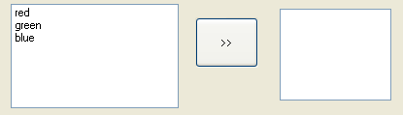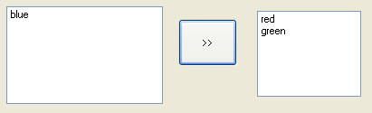
Private Sub Button1_Click(ByVal sender As System.Object, ByVal e As System.EventArgs) Handles Button1.Click

Dim Item As String
'"Here are the multiple selected items: "

For Each Item In ListBox1.SelectedItems
ListBox2.Items.Add(Item.ToString())

Next

While ListBox1.SelectedItems.Count > 0
ListBox1.Items.Remove(ListBox1.SelectedItem)
End While

'single selected item
If ListBox1.SelectedIndex <> -1 Then
ListBox2.Items.Add(ListBox1.SelectedItem.ToString())
If ListBox1.SelectedIndex <> -1 Then
ListBox1.Items.RemoveAt(ListBox1.SelectedIndex)
End If

End If
End Sub
On item click:
Private Sub ListBox1_SelectedIndexChanged(ByVal sender As System.Object, ByVal e As System.EventArgs) Handles ListBox1.SelectedIndexChanged

'single selected
If ListBox1.SelectedIndex <> -1 Then
ListBox2.Items.Add(ListBox1.SelectedItem.ToString())
If ListBox1.SelectedIndex <> -1 Then
ListBox1.Items.RemoveAt(ListBox1.SelectedIndex)
End If

End If
End Sub

Changing picture in picture box using openfile dialog box:
Private Sub Button2_Click(ByVal sender As System.Object, ByVal e As System.EventArgs) Handles Button2.Click
If OpenFileDialog1.ShowDialog() = DialogResult.OK Then
s = OpenFileDialog1.FileName
TextBox1.Text = s
PictureBox1.Image = Image.FromFile(s)
End If
End Sub

Working with dialog boxes:
Imports System.IO
Public Class Form1

Private Sub Button1_Click(ByVal sender As System.Object, ByVal e As System.EventArgs) Handles Button1.Click
RichTextBox1.Text = " "
'clears the text in richtextbox
End Sub

Private FileName As String
'declaring filename that will be selected
Dim sr As StreamReader
'streamreader is used to read text

Private Sub OpenToolStripMenuItem_Click(ByVal sender As System.Object, ByVal e As System.EventArgs) Handles OpenToolStripMenuItem.Click
Try
With OpenFileDialog1
'With statement is used to execute statements using a particular object, here,_
'OpenFileDialog1
.Filter = "Text files (*.txt)|*.txt|" & "All files|*.*"
'setting filters so that Text files and All Files choice appears in the Files of Type box
'in the dialog
If .ShowDialog() = Windows.Forms.DialogResult.OK Then
'showDialog method makes the dialog box visible at run time
FileName = .FileName
sr = New StreamReader(.OpenFile)
'using streamreader to read the opened text file
RichTextBox1.Text = sr.ReadToEnd()
'displaying text from streamreader in richtextbox
End If
End With
Catch es As Exception
MessageBox.Show(es.Message)
Finally
If Not (sr Is Nothing) Then
sr.Close()
End If
End Try
End Sub

Private Sub SaveToolStripMenuItem_Click(ByVal sender As System.Object, ByVal e As System.EventArgs) Handles SaveToolStripMenuItem.Click
Dim sw As StreamWriter
'streamwriter is used to write text
Try
With SaveFileDialog1
.FileName = FileName
.Filter = "Text files (*.txt)|*.txt|" & "All files|*.*"
If .ShowDialog() = Windows.Forms.DialogResult.OK Then
FileName = .FileName
sw = New StreamWriter(FileName)
'using streamwriter to write text from richtextbox and saving it
sw.Write(RichTextBox1.Text)
End If
End With
Catch es As Exception
MessageBox.Show(es.Message)
Finally
If Not (sw Is Nothing) Then
sw.Close()
End If
End Try
End Sub

Private Sub FontToolStripMenuItem_Click(ByVal sender As System.Object, ByVal e As System.EventArgs) Handles FontToolStripMenuItem.Click
Try
With FontDialog1
.Font = RichTextBox1.Font
'initializing the dialog box to match the font used in the richtextbox
.Color = RichTextBox1.ForeColor
'default color is Black
If .ShowDialog = Windows.Forms.DialogResult.OK Then
setFont()
'calling a method setFont() to set the selected font and color
End If
End With
Catch es As Exception
MessageBox.Show(es.Message)
End Try
End Sub
Private Sub setFont()
Try
With FontDialog1
RichTextBox1.Font = .Font
If .ShowColor Then
RichTextBox1.ForeColor = .Color
'setting the color
End If
End With
Catch ex As Exception
MessageBox.Show(ex.Message)
End Try
End Sub

Private Sub ColorToolStripMenuItem_Click(ByVal sender As System.Object, ByVal e As System.EventArgs) Handles ColorToolStripMenuItem.Click
Static CustomColors() As Integer = {RGB(255, 0, 0), RGB(0, 255, 0), RGB(0, 0, 255)}
'initializing CustomColors with an array of integers and putting Red, Green,
'and Blue in the custom colors section
Try
With ColorDialog1
.Color = RichTextBox1.ForeColor
'initializing the selected color to match the color currently used
'by the richtextbox's foreground color
.CustomColors = CustomColors
'filling custom colors on the dialog box with the array declared above
If .ShowDialog() = Windows.Forms.DialogResult.OK Then
RichTextBox1.ForeColor = .Color
CustomColors = .CustomColors
'Storing the custom colors to use again
End If
ColorDialog1.Reset()
'resetting all colors in the dialog box
End With
Catch es As Exception
MessageBox.Show(es.Message)
End Try
End Sub

Private Sub Form1_Load(ByVal sender As System.Object, ByVal e As System.EventArgs) Handles MyBase.Load

End Sub
End Class

Progress bar: (using timer)
Dim f2 As New Form2

Private Sub Form3_Load(ByVal sender As System.Object, ByVal e As System.EventArgs) Handles MyBase.Load

ProgressBar1.Step = 21
ProgressBar1.Value = 0
Button4.Enabled = False
Timer1.Enabled = True

End Sub
Private Sub Timer1_Tick(ByVal sender As System.Object, ByVal e As System.EventArgs) Handles Timer1.Tick

ProgressBar1.PerformStep()
If ProgressBar1.Value >= ProgressBar1.Maximum Then
Timer1.Enabled = False
Button4.Enabled = True
f2.Show()
Me.Hide()
End If
End Sub

